**Proposal on**

**FIN**

(Friend In Need)

**Prepared** **for**

1. **K. M. Ahsanul Hoque, Adjunct professor**

**Tashreef Muhammad, Adjunct Faculty**

**Prepared by**

**Lab Section: B2**

**Kh. Rifat Amin, 180204116**

**Fazlay Elahi Safin, 180204119**

**Sanjida Aziz Tonny, 180204122**

**Md Zahidul Haque, 180204136**

**S.M Tasnimul Hasan, 180204142**

**Date: 08/03/2022**



**Ahsanullah University of Science and Technology**

**Department of Computer Science and Engineering**

**Executive Summary**

FIN App is basically an emergency application for mass people. Through this app users will get help in various kind of emergency situations.

There are lot of people who face problems in finding blood donors when needed. Sometimes blood banks are out of blood. They have to contact with lot of people then. Even though there are lot of people around us who donates blood, we can’t find their information when needed.

Another kind of emergency situation we face to find locations. When people go to any new area, they have no idea about that place. Sometimes people get lost, or may face any kind of dangerous situation. They might need to reach people immediately or need to reach nearby help station.

We need a friend who can help us whenever we need. We may face this kind of difficulty in our everyday life. But people are busy with their own life. How can anyone be standby with a person! So, we came up with a solution. Every person of these days carries phone with them. So, we are building an android app which can help a person like a “Friend In Need”.

**Table of Contents**

|  |  |
| --- | --- |
| **Contents** | **Page no** |
| 1. **Letter of Transmittal** | 03 |
| 1. **Introduction** | 04 |
| * 1. **Project Introduction**   2. **Team Introduction** |  |
| 1. **Background of the Study** | 04 |
| * 1. **Project background** |  |
| 1. **Objectives**    1. **Primary Objective**    2. **Secondary Objective** | 05 |
| 1. **Methodology** | 05 |
| * 1. **Process Model** |  |
| 1. **The Project** |  |
| * 1. **Communication** | 07 |
| * 1. **Planning** | 09 |
| * 1. **Modeling** | 14 |
| * 1. **Construction**   2. **Deployment**   3. **Learning Experiences** | 35  35  35 |
| * 1. **Conclusion** | 36 |
| * 1. **Bibliography/References:** | 36 |
| **Appendix** | 36 |

**Letter of Transmittal**

March 8, 2022

A. K. M. Ahsanul Hoque

Assistant professor

Ahsanullah University of Science and Technology

Tejgaon Industrial Area, Dhaka

**Subject: Submission of project proposal on android app FIN**

Sir,

We are submitting herewith our project proposal entitled ‘FIN’ as partial fulfillment of the CSE 3224 course requirements.

This project proposal details our android app description, project background, objectives, working process method, client communication, work plan, estimation, feasibility analysis, project modeling, construction requirements and so on.

We hope that this proposal will thoroughly reflect our project plan. If you have any additional questions that you want to ask, feel free to contact us anytime. Please review the report and let us know your thoughts.

Sincerely,

Kh. Rifat Amin, ID: 180204116

Fazlay Elahi Safin, ID: 180204119

Sanjida Aziz Tonny, ID: 180204122

Md Zahidul Haque, ID: 180204136

1. M Tasnimul Hasan, ID: 180204142

**Introduction**

1. **Project Introduction:**

This app is to provide Emergency services, which helps a person to find a Hospital, Police Station, Pharmacy, ATM Booth and Filling Stations nearest to his location. In this location-based system, our app will use GPS to detect the person’s live location. Person can send his/her current location to anyone via SMS by one tap. Even if he doesn't have an active internet connection then a SOS number will be just one click away. A person can log in to get more features. Through this app person can find blood donor according to his/her need. All over this is a project for a person’s emergency and need.

1. **Team Introduction:**
2. Name: **Kh. Rifat Amin**

ID: 180204116

1. Name: **Fazlay Elahi Safin**

ID: 180204119

1. Name: **Sanjida Aziz Tonny**

ID: 180204122

1. Name: **Md Zahidul Haque**

ID: 180204136

1. Name: **S.M Tasnimul Hasan**

ID: 180204142

**Background of the Study**

**Project Background:**

Every day we open newspaper or TV channel or social media, we see news of accidents, rape, murder, snatching, theft etc. During pandemic situation this kind of tragedy has become very common. Different reasons are behind these incidents. Unfortunately, in our country, safety issues are very disregarded.

Some of these tragic scenarios may needed help. Maybe victims could survive if they could get that help. Thinking of mass people’s safety, we have chosen this project which can help people and they can suffer less.

**Objectives**

1. **Primary Objective:**

In our busy life every person has to go out. People go to different places. Whether the place is unknown or known people may face difficulty or fall to any emergency situation.

Emergency situations can arise at anytime and anywhere. Usually, we seek helps from our friends, family, relatives. But in our busy life how can anyone be able to do help every time needed. People wish to have a friend who can help whenever he/she need. So, to accomplish people’s demand we’ve decided to create an app which can help in our needed time and emergency situations.

1. **Secondary Objectives:**

We wanted to build an app where all the necessary information for emergency situation can be found in one place. And people can be able to use all of these features easily. Thus, life can become easier and safer to live

**Methodology**

**Process Model:**

A process is a collection of activities, actions and tasks that are performed when some work product is to be created. It enables the people doing the work to pick and choose the appropriate set of work actions and tasks... Software development process defines which member of the development team is doing which part, the timing in relation to other activities and the details and steps in the activity. Communication, planning, modeling, constructions, deployment these are the basic phase of process. All of these phases together called process model. There are different types of process models based on the sequence and intercommunication between these phases. Ex: Traditional process models, Agile Models, The unified process etc.

In traditional process models, the flow of development is unidirectional, from communication to clients and then to planning and development, then to testing and maintenance. This model is based on pre-organized phases of the software development life cycle. Some traditional models are:

1. Waterfall Model
2. Incremental Model
3. Prototyping Model

4. Spiral Model

In this project we will use a Traditional process Models and that is **Incremental** Model. In this model-

- Multiple independent deliveries are identified.

- Within an increment, work flow is linear within an increment and is staggered between increments.

- focuses on an operational product with each increment

- Iterative in nature.

- Provides a needed set of functionalities sooner while delivering optional

components later

- Useful when staffing is too short for a full-scale development and when requirements are well understood.

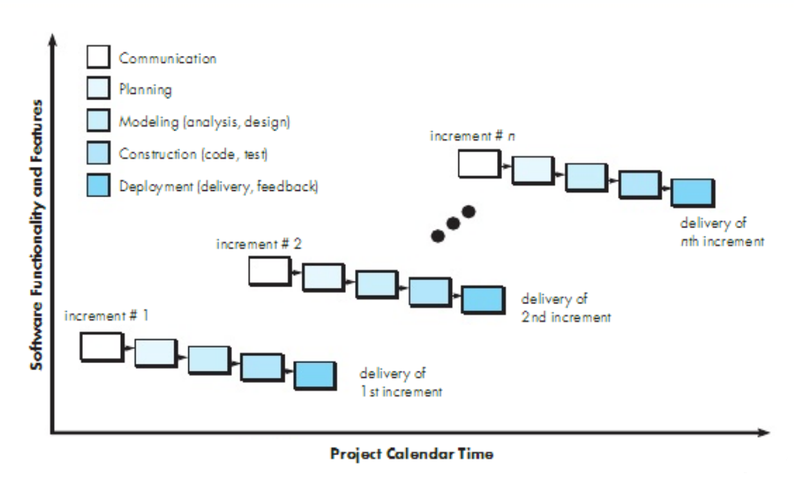

**Figure: Incremental Model**

In our project, work will be divided into some modules. Each module will be done independently by different team members. These individual work modules will perform all phases of process separately. As our project requirements has been well understood and identified this process model will be useful for us. So, we have chosen incremental process model for our project.

**The Project**

**1. Communication**

**Survey**

To have a better understanding of how “FIN” appears to its target audience, as well as what they think about the current situation. The poll was conducted via social media. The results of our poll are listed below.

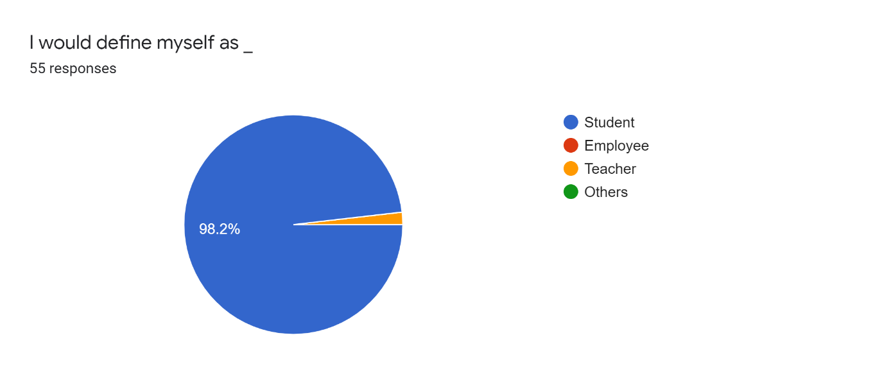

We're attempting to determine which aspects of our website are of interest to visitors. This website appears to be of interest to students and teachers alike.

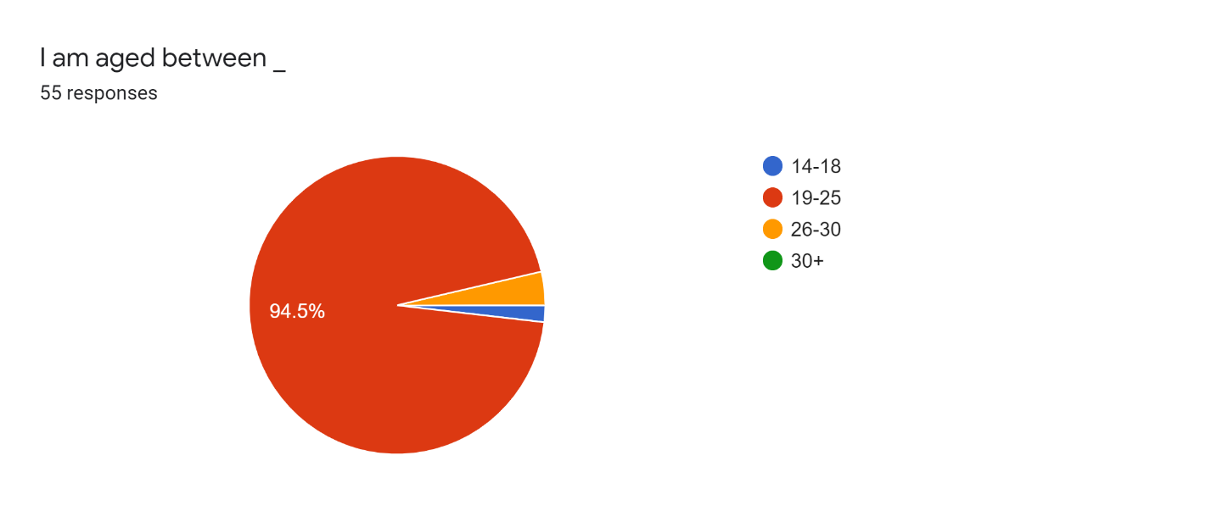

We're attempting to determine which age groups are interested in our website. People between the ages of 19 and 25 appear to be the most interested, followed by those under the age of 25.

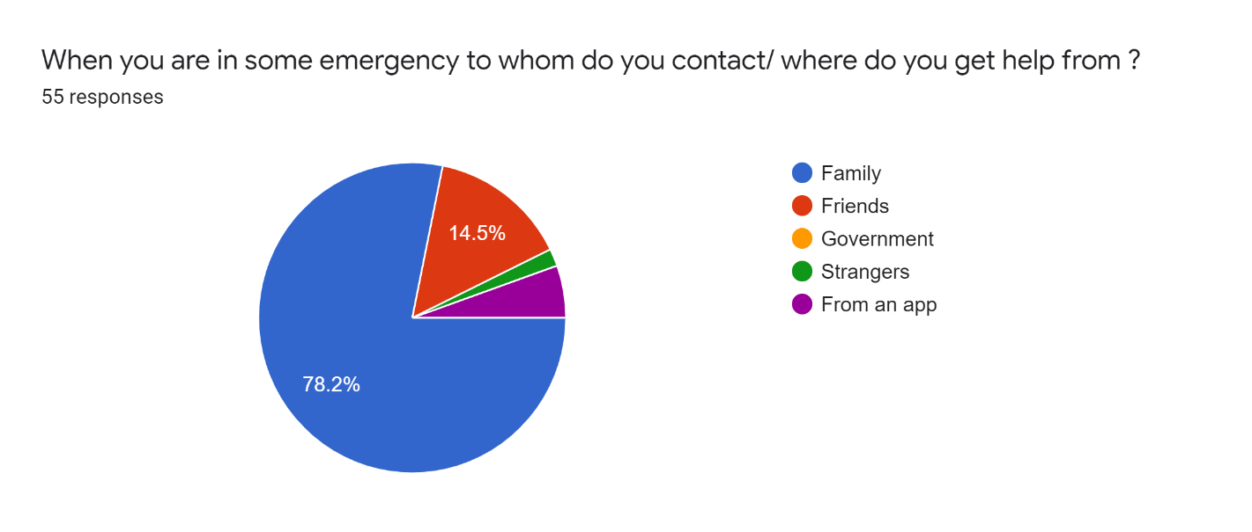

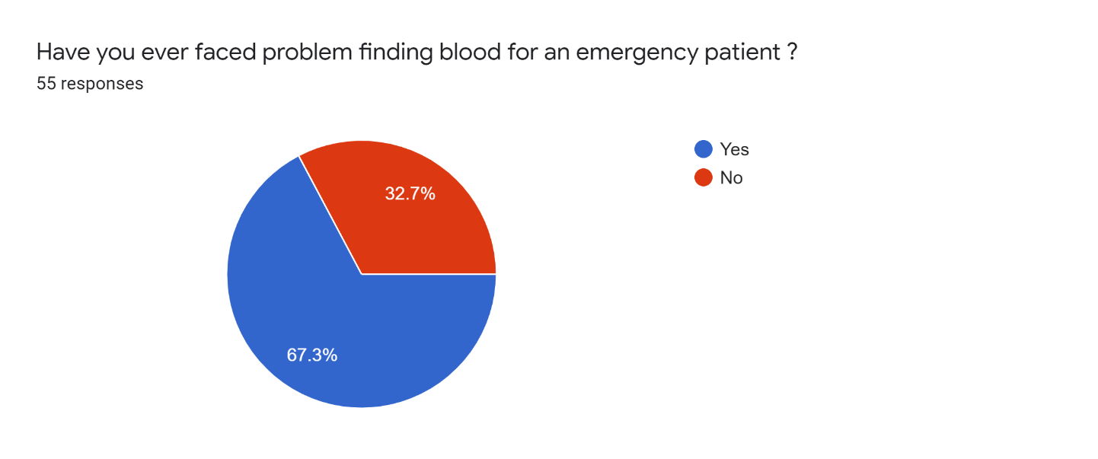

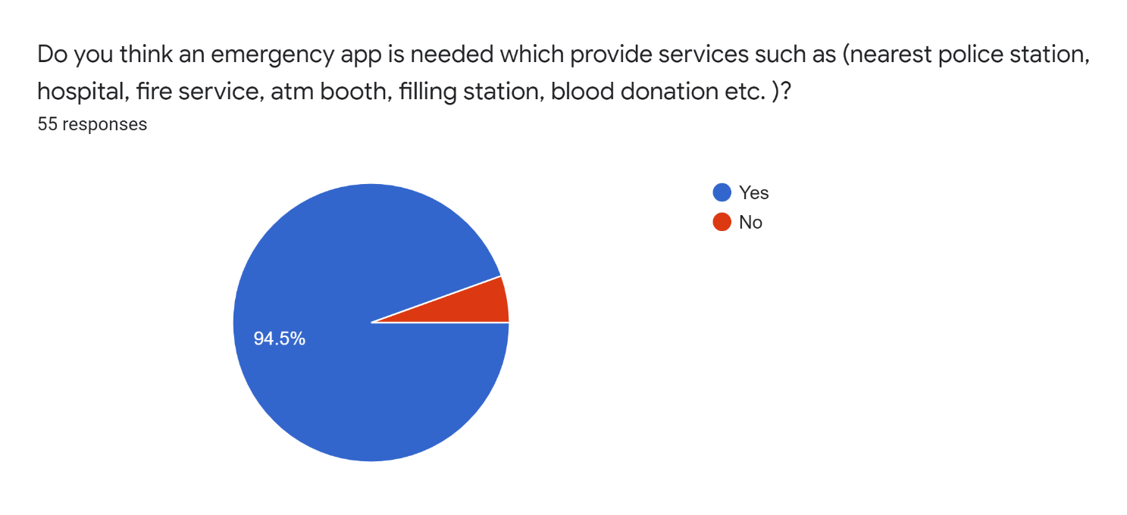

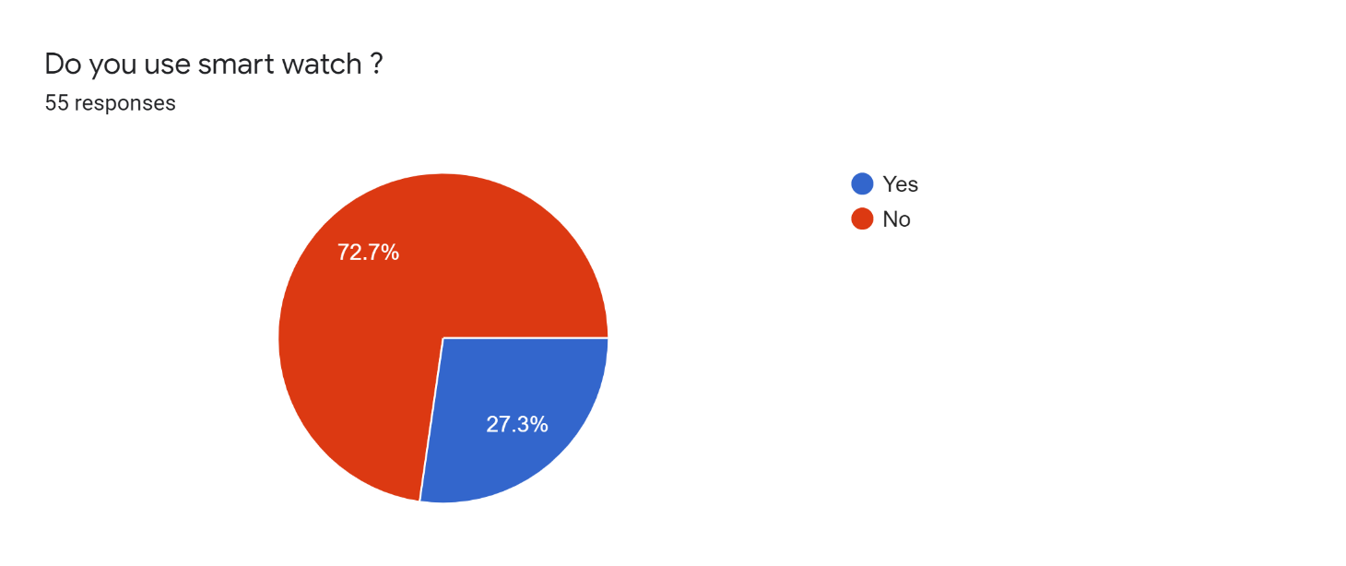

**2. Planning**

**a. PERT**

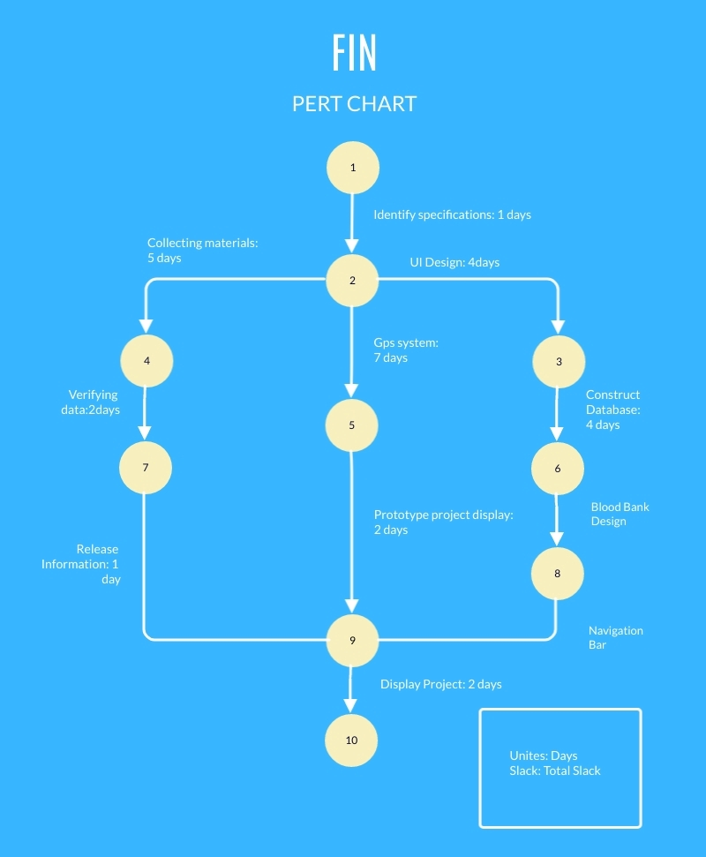

**b .CPM**

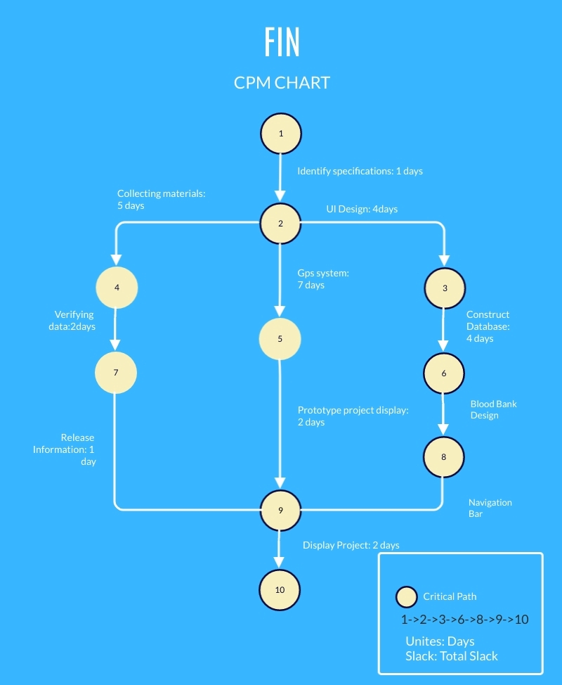

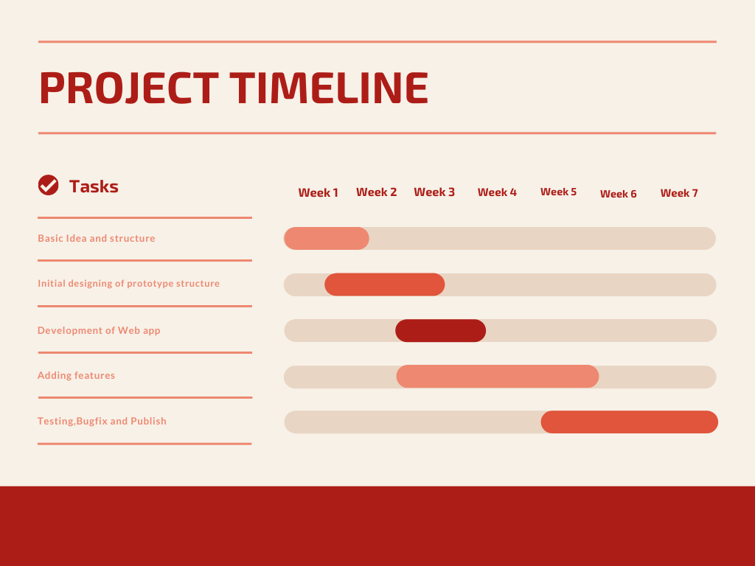**c. Gantt Chart / Time Chart**

**d. Project Planning**

We have planned our project with five processes. Those area given below

1. We will have full basic idea of project and structures within 1 week.
2. Then initial design for the project structure in between week 1 to week 3
3. Then the development of the project will be starting from end of the week 2 to week 6
4. Then features addition will be completed between end of the week 2 to middle of the week 6
5. Then end of the 5th week to final 7th week we will be fixing bugs and then submit the project.

**e. Software Estimation**

**1. FP Estimation**

|  |  |  |  |
| --- | --- | --- | --- |
| **Measurement Parameter** | **Count** |  | **Weighing factor** |
| 1. Number of external inputs (EI) | 24 | * | 4 = 96 |
| 2. Number of external outputs (EO) | 46 | * | 4 = 184 |
| 3. Number of external inquiries (EQ) | 8 | * | 6 = 48 |
| 4. Number of internal files (ILF) | 4 | * | 10 = 40 |
| 5. Number of external interfaces (EIF) Count-total → | 2 | * | 5 = 10 378 |

So, sum of all fi (i ← 1 to 14) = 4 + 1 + 0 + 3 + 5 + 4 + 4 + 3 + 3 + 2 + 2 + 4 + 5 = 43

FP = Count-total * [0.65 + 0.01 *∑(fi)]  
 = 378 * [0.65 + 0.01 * 43]  
 = 378 * [0.65 + 0.43]  
 = 378 * 1.08 = 408

**2. Process Based Estimation**

The most common technique for estimating a project is to base the estimate on the process that will be used. That is, the process is decomposed into a relatively small set of tasks and the effort required to accomplish each task is estimated. Like the problem-based techniques, process-based estimation begins with a delineation of software functions obtained from the project scope. A series of software process activities must be performed for each function. Functions and related software process activities may be represented as part of a table.

**f.Project Estimation**

We plan to finish our project in 7 weeks as per lab timing. This project has a lot of area for improvement in the future. The risk about this project is to eliminate the threats that have been on other similar applications and websites also data safety of users. But we are making the best possible way to avoid this issue.

**g.Cost Benefit Analysis**

The cost of this project we initially find out that would be:

|  |  |
| --- | --- |
| Costs | In 12 Months (BDT) |
| Upload In Play Store | 5000 |
| Software Engineer | 100,000 (1 Month) |
| App Developer | 65,000 |
| Advertisement | 40,000 |
| Hidden Cost | 30,000 |
| Maintenance Cost | 50,000 |
| Total | **290,000** |

The cost of the project is based on our work time. We will be working 20 hours weekly. So based on it, the cost of this project is 290,000 Taka BDT in the starting year.

**h. Training**

Software Engineering Training customized as Software Requirements, Definition, Development & Management Training. This is intended for those wishing to learn about the best software engineering practices. It means the practical introduction to software development and specifically methods to elicit, analyze, define and manage requirements. Software Engineering Training teaches One about the technical best practices, and how, in a changing environment, to communicate and manage requirements.

Who should do this:

* Software developers
* Software engineers
* System engineers
* Test engineers
* Project Managers (PM)
* Testing, Verification & Validation and Configuration PM

**i.Risk Analysis**

Risk analysis in software testing is an approach to software testing where software risk is analyzed and measured. Traditional software testing normally looks at relatively straight-forward function testing . A software risk analysis looks at code violations that present a threat to the stability, security, or performance of the code. Complex applications using multiple frameworks and languages can present flaws that are extremely difficult to find and tend to cause the largest software disruptions.

**j.Resource requirements**

Resources we will need:

● 2 System Analyst and planner

● 3-5 Programmers

**k. Feasibility Study**

1. **Operational Feasibility**

* **Control:** The data of users will remain secured throughout this application; the risk of data loss will be minimized.
* **Efficiency:**
* Firebase database and Android Studio software will be used throughout this application, therefore the soft-wares will make sure the application performs efficiently.
* Maximum best output is provided to this application.
* **Services:**
* User can create an account to access all the features
* User can search for nearby Hospital, Police Station, Pharmacy, ATM Booth & Fuel Station when they need emergency

1. **Economical Feasibility**

We have drafted a break-even analysis temporarily.

|  |  |  |  |
| --- | --- | --- | --- |
| Year | Costs | Profit (BDT) | Net Profit (BDT) |
| 1st Year | 290,000 | 180,000 | -110,000 |
| 2nd Year | 290,000 | 320,000 | 30,000 |
| 3rd Year | 290,000 | 470,000 | 180,000 |

1. **Technical Feasibility**

* Assessing technical feasibility includes evaluating the ability of computer hardware and software to handle workloads adequately.
* Estimating Workloads and database or storage capacity.

1. **Legal Feasibility**

At this time, there are no potential legal or copyright difficulties with our project.

**3. Modeling:**

**a. Project Features**

* Hospital Service
* Police station Service
* Fire Service
* Pharmacy
* ATM Booth
* Fuel Station
* Location Sending to Emergency Contact
* Blood bank

**b. Function Definations and Description**

|  |  |  |  |  |  |  |  |  |  |  |
| --- | --- | --- | --- | --- | --- | --- | --- | --- | --- | --- |
|  | Function Name | |  | |  |  | Hospital |  | |  |
|  |  |  |  |  |  |  |  |  |  |  |
|  |  |  |  |  |  |  |  |  |  |  |
|  | Description | |  | |  |  | In this location-based system, our app will use GPS to detect persons live location. Users can find near-by hospitals in any emergency situation |  | |  |
|  |  |  |  |  |  |  |  |  |  |  |
|  |  |  |  |  |  |  |  |  |  |  |
|  | Precondition | |  | |  |  | None or Login |  | |  |
|  |  |  |  |  |  |  |  |  |  |  |
|  |  |  |  |  |  |  |  |  |  |  |
|  | Function Name | |  |  |  |  | Pharmacy |  |  |  |
|  |  |  |  |  |  |  |  |
|  |  |  |  |  |  |  |  |  |  |  |
|  |  |  |  |  |  |  |  |  |  |  |
|  | Scenario | |  |  |  |  | In this location-based system, our app will use GPS to detect persons live location. Users can find near-by pharmacies from anywhere |  |  |  |
|  |  |  |  |  |  |  |  |
|  |  |  |  |  |  |  |  |  |  |  |
|  |  |  |  |  |  |  |  |  |  |  |
|  | |  |  |  |  |  |  |  |  |  |
|  | Precondition | |  |  |  |  | None or Login |  |  |  |
|  |  |  |  |  |  |  |  |  |  |  |
|  | |  |  |  |  |  |  |  |  |  |
|  | | |  |  |  |  |  |  |  |  |
|  | Function Name |  |  |  |  | ATM Booth | | |  |  |
|  |  |  |  |  |  |  |  |  |  |  |
|  |  |  |  |  |  |  |  |  |  |  |
|  | Scenario |  |  |  |  | In this location-based system, our app will use GPS to detect persons live location. Users can find the nearest location of their desired ATM booths | | |  |  |
|  |  |  |  |  |  |  |
|  |  |  |  |  |  |  |  |  |  |  |
|  |  |  |  |  |  |  |  |  |  |  |
|  | | |  |  |  |  |  |  |  |  |
|  | Precondition |  |  |  |  | None or Login | | |  |  |
|  |  |  |  |  |  |  |  |  |  |  |
|  | | |  | |  |  |  |  |  |  |
|  | Function Name | |  | |  |  | Police Station | |  |  |
|  |  |  |  |  |  |  |  |  |  |  |
|  |  |  |  |  |  |  |  |  |  |  |
|  | Scenario | |  | |  |  | In this location-based system, our app will use GPS to detect persons live location. Users can contact any near-by police station for any emergency need | |  |  |
|  |  |  |  |  |  |  |  |  |  |  |
|  |  |  |  |  |  |  |  |  |  |  |
|  | Precondition | |  | |  |  | None or Login | |  |  |
|  |  |  |  |  |  |  |  |  |  |  |

|  |  |  |  |  |  |  |  |  |  |  |
| --- | --- | --- | --- | --- | --- | --- | --- | --- | --- | --- |
|  | Function Name | |  | |  |  | Fuel Station | |  |  |
|  |  |  |  |  |  |  |  |  |  |  |
|  |  |  |  |  |  |  |  |  |  |  |
|  | Scenario | |  | |  |  | In this location-based system, our app will use GPS to detect persons live location. Users can search for the nearest location of fuel stations | |  |  |
|  |  |  |  |  |  |  |  |  |  |  |
|  |  |  |  |  |  |  |  |  |  |  |
|  | Precondition | |  | |  |  | None | |  |  |
|  |  |  |  |  |  |  |  |  |  |  |

|  |  |  |  |  |  |  |  |  |  |  |
| --- | --- | --- | --- | --- | --- | --- | --- | --- | --- | --- |
|  | Function Name | |  | |  |  | Call 999 |  | |  |
|  |  |  |  |  |  |  |  |  |  |  |
|  |  |  |  |  |  |  |  |  |  |  |
|  | Scenario | |  | |  |  | If the user doesn’t have an active internet connection, then he/she can use government emergency helpline service 999 |  | |  |
|  |  |  |  |  |  |  |  |  |  |  |
|  |  |  |  |  |  |  |  |  |  |  |
|  | Precondition | |  | |  |  | None |  | |  |
|  |  | |  | |  |  |  |  | |  |
|  | Function Name | |  | |  |  | Blood Bank |
|  |  | |  | |  |  |  |
|  | Scenario |  |  |  |  |  | User can locate blood donor according to his need |
|  |  |  |  |  |  |  |  |
|  | Precondition | |  | |  |  | Login |

**c. Use Case Diagram**

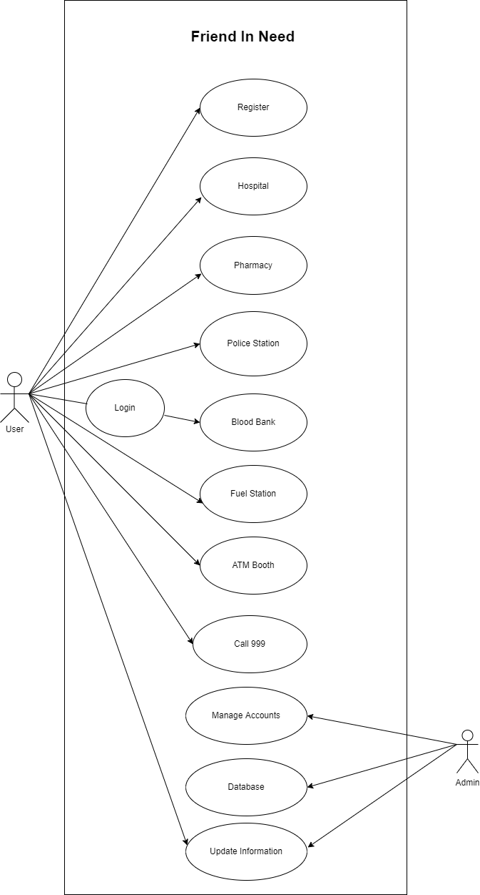

**c.i. Use case narratives**

|  |  |
| --- | --- |
| **ID:** | 5001 |
| **Title:** | Hospital |
| **Description:** | In this location-based system, our app will use GPS to detect persons live location. Users can find near-by hospitals in any emergency situation |
| **Primary Actor:** | User |
| **Preconditions:** | Android Device, Internet Connection & Login |
| **Postconditions:** | Install/Update google map from play store |
| **Main  Success Scenario:** | Users can find near-by hospitals in any emergency situation at anywhere |
| **Extensions:** | If the user doesn’t have internet connection, he/she will not be able to access this feature |
| **Frequency of Use:** | Always when user need |
| **Status:** | Under Development |
| **Owner:** | S. M. Tasnimul Hasan |
| **Priority:** | High |

|  |  |
| --- | --- |
| **ID:** | 5002 |
| **Title:** | Pharmacy |
| **Description:** | In this location-based system, our app will use GPS to detect persons live location. Users can find near-by pharmacies from anywhere |
| **Primary Actor:** | User |
| **Preconditions:** | Android Device, Internet Connection & Login |
| **Postconditions:** | Install/Update google map from play store |
| **Main  Success Scenario:** | Users can find near-by pharmacies in any emergency situation at anywhere |
| **Extensions:** | If the user doesn’t have internet connection, he/she will not be able to access this feature |
| **Frequency of Use:** | Always when user need |
| **Status:** | Under Development |
| **Owner:** | Sanjida Aziz Tonny |
| **Priority:** | High |

|  |  |
| --- | --- |
| **ID:** | 5003 |
| **Title:** | ATM Booth |
| **Description:** | In this location-based system, our app will use GPS to detect persons live location. Users can find the nearest location of their desired ATM booths |
| **Primary Actor:** | User |
| **Preconditions:** | Android Device, Internet Connection & Login |
| **Postconditions:** | Install/Update google map from play store |
| **Main  Success Scenario:** | Users can find the nearest location of their desired ATM booths at anywhere |
| **Extensions:** | If the user doesn’t have internet connection, he/she will not be able to access this feature |
| **Frequency of Use:** | Always when user need |
| **Status:** | Under Development |
| **Owner:** | Md Zahidul Haque |
| **Priority:** | High |

|  |  |
| --- | --- |
| **ID:** | 5004 |
| **Title:** | Police Station |
| **Description:** | In this location-based system, our app will use GPS to detect persons live location. Users can contact any near-by police station for any emergency need |
| **Primary Actor:** | User |
| **Preconditions:** | Android Device, Internet Connection & Login |
| **Postconditions:** | Install/Update google map from play store |
| **Main  Success Scenario:** | Users can contact any near-by police station for any emergency need at anywhere |
| **Extensions:** | If the user doesn’t have internet connection, he/she will not be able to access this feature |
| **Frequency of Use:** | Always when user need |
| **Status:** | Under Development |
| **Owner:** | Fazlay Elahi Safin |
| **Priority:** | High |

|  |  |
| --- | --- |
| **ID:** | 5005 |
| **Title:** | Fuel Station |
| **Description:** | In this location-based system, our app will use GPS to detect persons live location. Users can search for the nearest location of fuel stations |
| **Primary Actor:** | User |
| **Preconditions:** | Android Device, Internet Connection & Login |
| **Postconditions:** | Install/Update google map from play store |
| **Main  Success Scenario:** | Users can search for the nearest location of fuel stations at anywhere |
| **Extensions:** | If the user doesn’t have internet connection, he/she will not be able to access this feature |
| **Frequency of Use:** | Always when user need |
| **Status:** | Under Development |
| **Owner:** | Fazlay Elahi Safin & Kh Rifat Amin |
| **Priority:** | High |

|  |  |
| --- | --- |
| **ID:** | 5006 |
| **Title:** | Call 999 |
| **Description:** | If the user doesn’t have an active internet connection, then he/she can use government emergency helpline service 999 |
| **Primary Actor:** | User |
| **Preconditions:** | Android Device |
| **Postconditions:** | Install/Update google map from play store |
| **Main  Success Scenario:** | User can use government emergency helpline service 999 when they don’t have internet connection |
| **Extensions:** | None |
| **Frequency of Use:** | Always when user need |
| **Status:** | Under Development |
| **Owner:** | Kh Rifat Amin & Sanjida Aziz Tonny |
| **Priority:** | High |

|  |  |
| --- | --- |
| **ID:** | 5007 |
| **Title:** | Blood Bank |
| **Description:** | Users can locate blood donor according to his need |
| **Primary Actor:** | User |
| **Preconditions:** | Android Device, Internet Connection & Login |
| **Postconditions:** | Install/Update google map from play store |
| **Main  Success Scenario:** | Users can find blood donor in emergency situation |
| **Extensions:** | If the user doesn’t have internet connection, he/she will not be able to access this feature |
| **Frequency of Use:** | Always when user need |
| **Status:** | Under Development |
| **Owner:** | S. M. Tasnimul Hasan & Md Zahidul Haque |
| **Priority:** | High |

**d.Class Diagram**

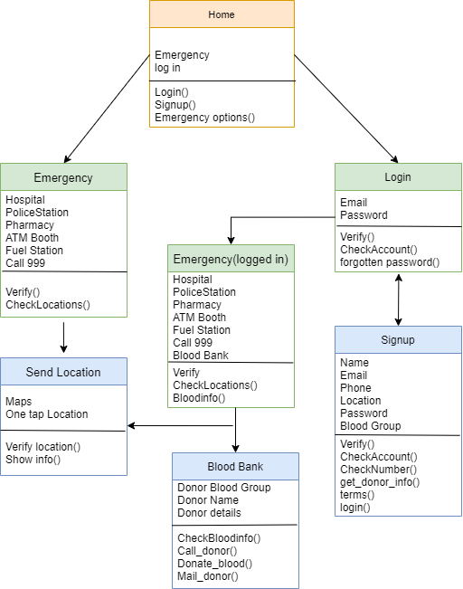

**d.i.CRC**

|  |  |
| --- | --- |
| **Class: Home** | |
| Home page for user after opening the application | |
| **Responsibility:** | **Collaborator:** |
| Creates user interface after opening the app | Emergency |
|
| Shows options of emergency and login | Login |

|  |  |
| --- | --- |
| **Class: Emergency** | |
| Emergency services without login | |
| **Responsibility:** | **Collaborator:** |
| Shows nearby Hospital, Police station, Pharmacy, ATM booth, Fuel station | Send Location |
| Direct Call to 999 |  |
| Shows send location service option |  |

|  |  |
| --- | --- |
| **Class: Send Location** | |
| Sending current location by one tap | |
| **Responsibility:** | **Collaborator:** |
| Choose contact number from phone |  |
| Enter phone number manually |  |
| Get current location and send to selected number |  |

|  |  |
| --- | --- |
| **Class: Login** | |
| User interface for login | |
| **Responsibility:** | **Collaborator:** |
| Takes user input for email and password. | Signup |
| Recovers password if forgotten | Emergency |
| Shows option for creating new account |  |

|  |  |
| --- | --- |
| **Class: Signup** | |
| User interface for login | |
| **Responsibility:** | **Collaborator:** |
| Takes user input for name, email, phone no, location, blood group, password | Login |
| Saves information as blood donor |  |
| Creates new user account |  |

|  |  |
| --- | --- |
| **Class: Emergency(logged in)** | |
| Emergency services logged in users | |
| **Responsibility:** | **Collaborator:** |
| Shows nearby Hospital, Police station, Pharmacy, ATM booth, Fuel station | Send Location |
| Direct Call to 999 | Blood Bank |
| Shows blood bank service option |  |
| Shows send location service option |  |

|  |  |
| --- | --- |
| **Class: Blood bank** | |
| Finding Blood donor from different groups | |
| **Responsibility:** | **Collaborator:** |
| Selects specific blood group |  |
| Shows donors from selected group |  |
| Gives detailed information about donors |  |

**e.Sequence Diagram**

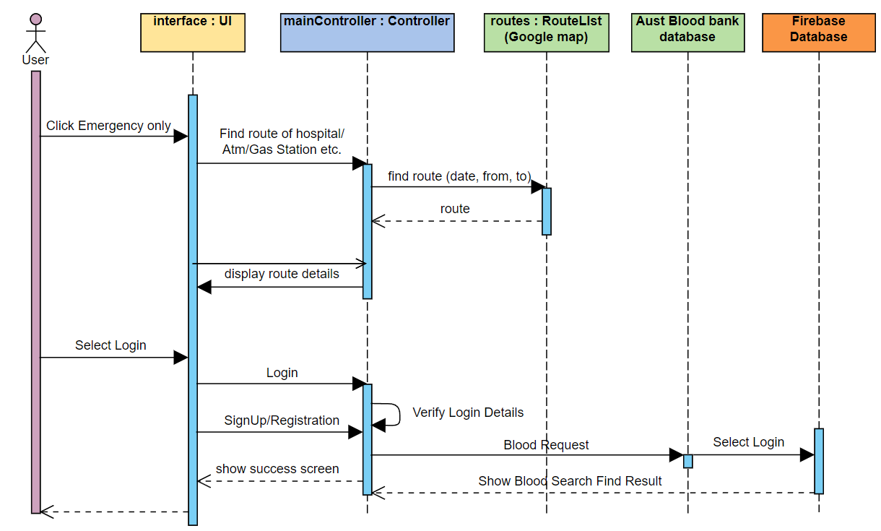

**f.Activity diagram**

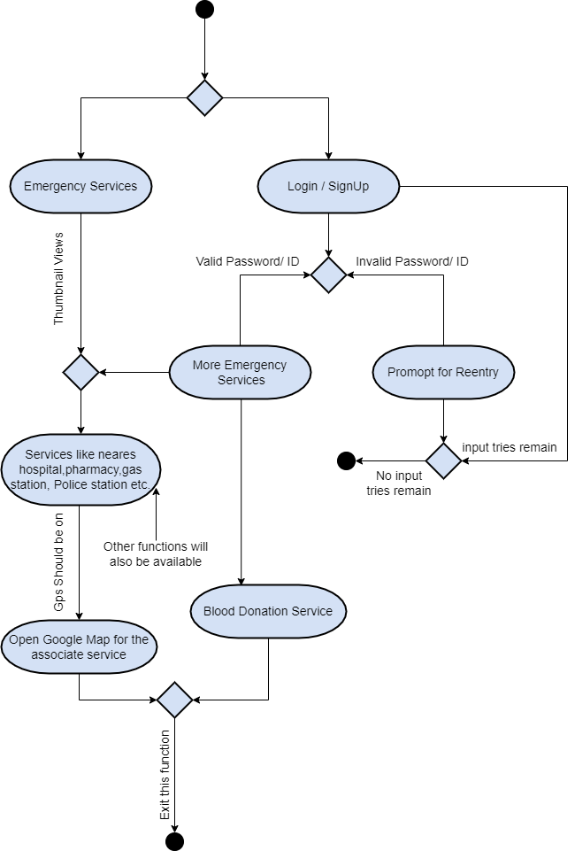

**g.Swim lane Diagram**

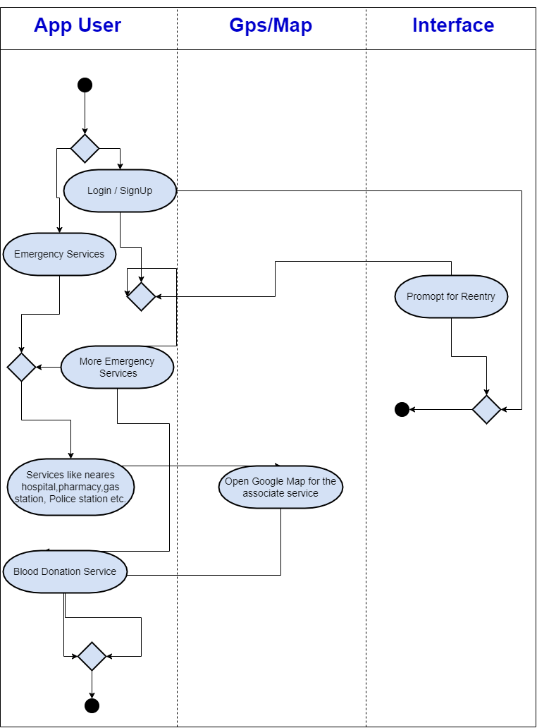

**h. Collaboration Diagram**

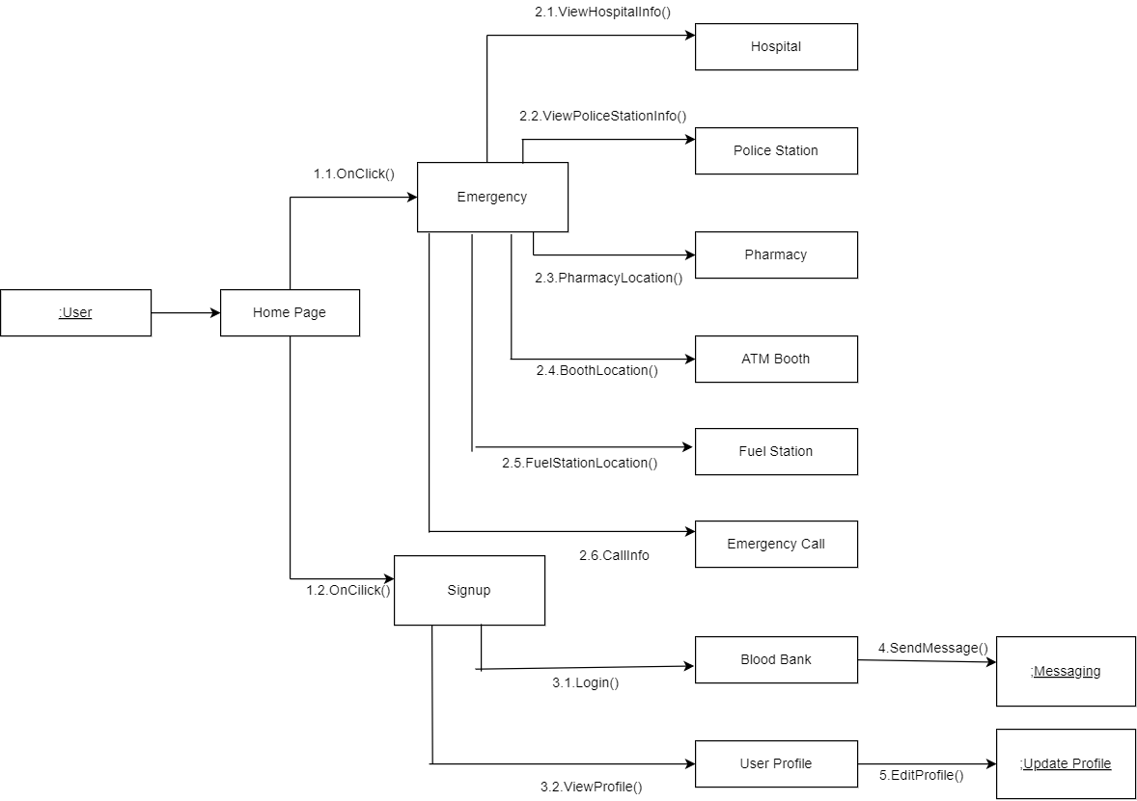

**i. Data Flow diagram**

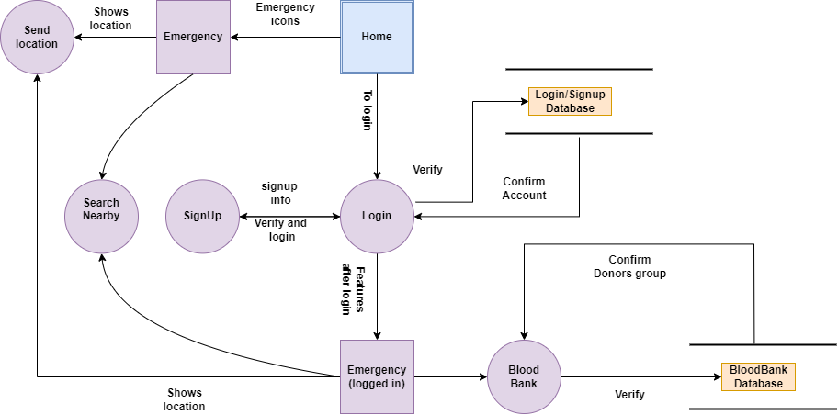

**j.Architecture Flow diagram**

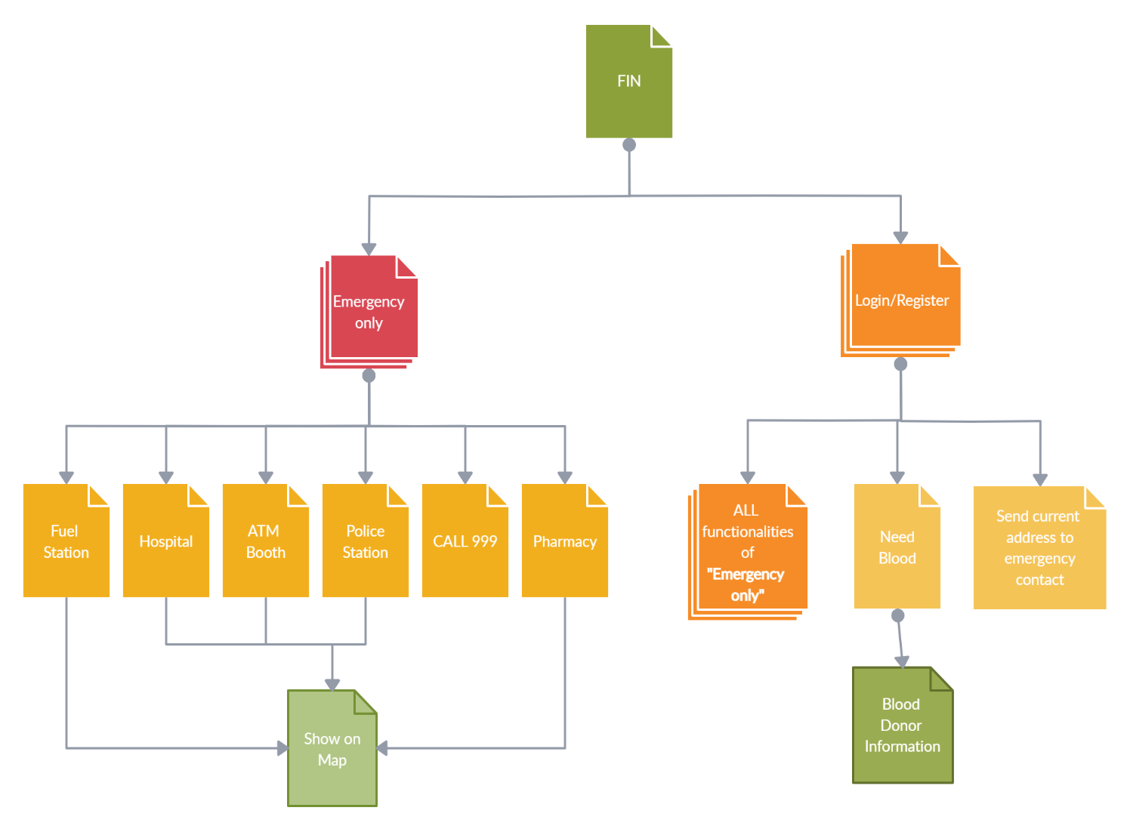

**k.UI/UX diagram**

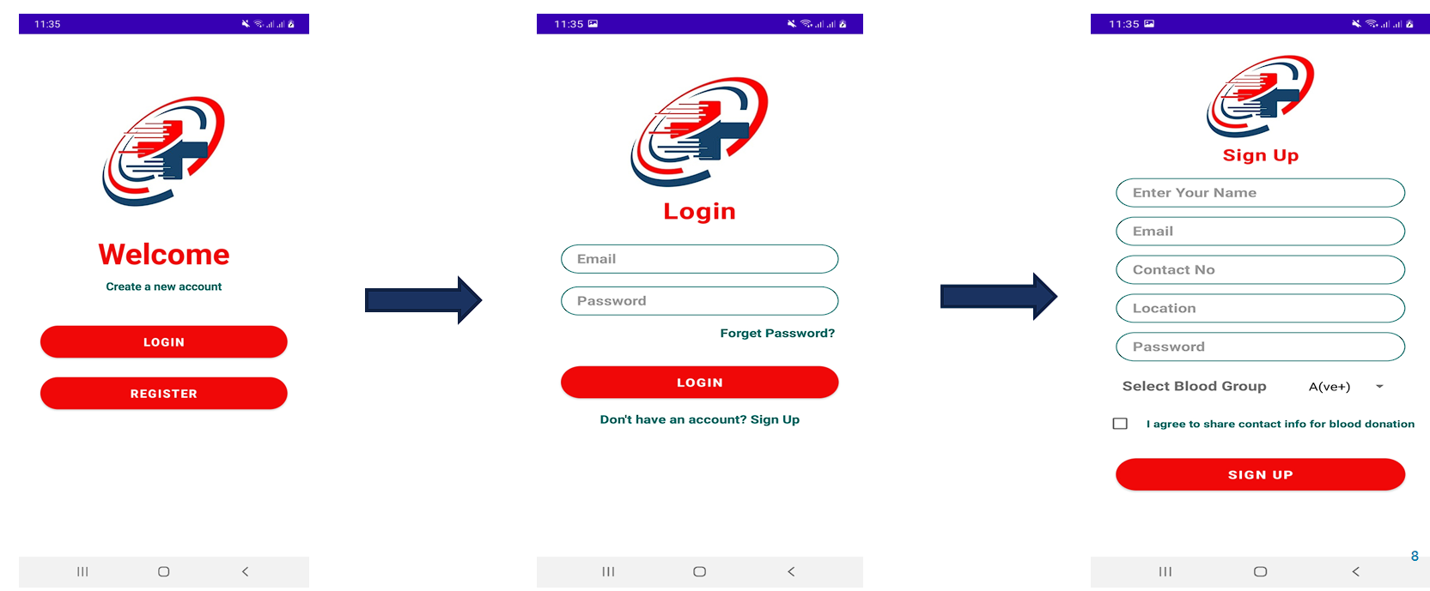

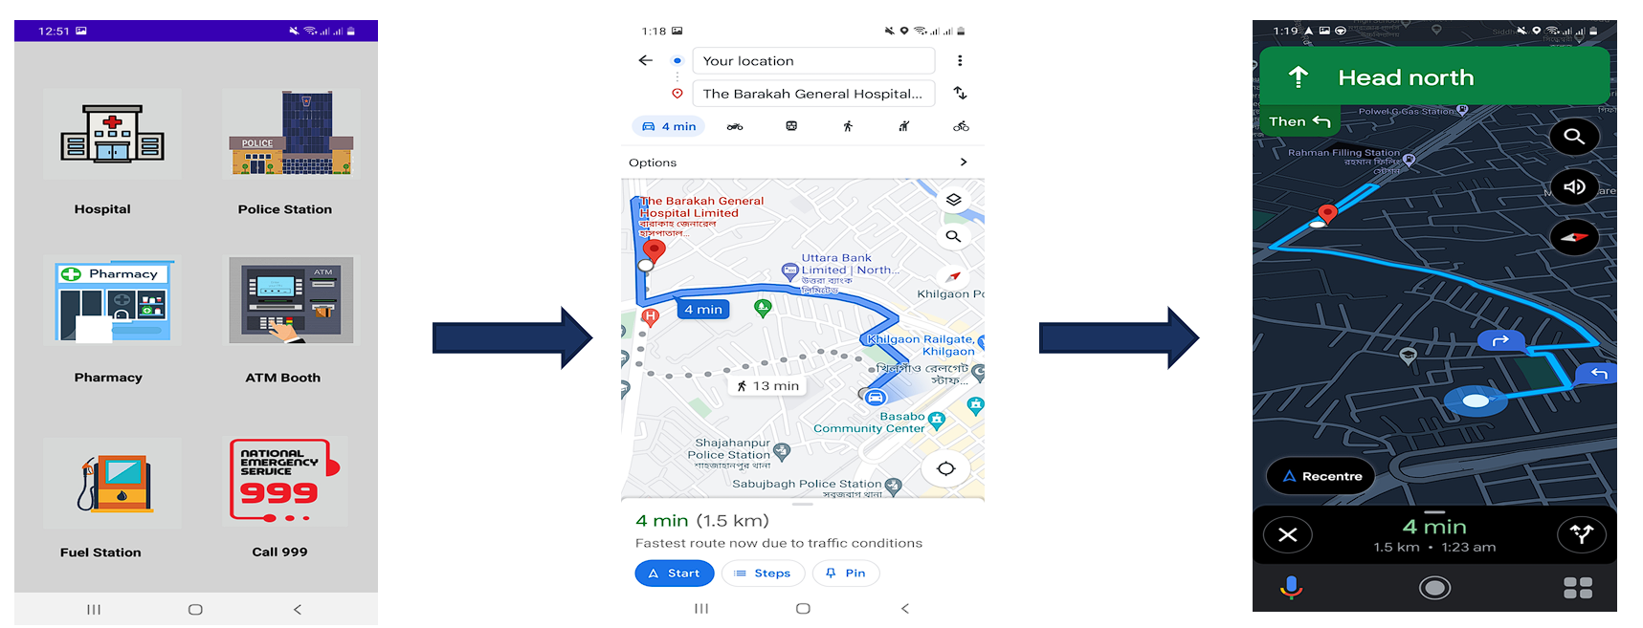

**l.** **Entities and Attributes**

|  |  |
| --- | --- |
| **Entity** | **Attributes** |
| **User** | user_id |
| user_name |
| user_phone |
| user_mail |
| user_password |
| user_sex |
| **Admin** | admin_id |
| User_id |
| admin_name |
| admin_mail |
| admin_phone |
| **Blood_Donor** | donor_id |
| User_id |
| donor_BloodGroup |
| donor_age |
| donor_address |

**m.Schema Diagram**

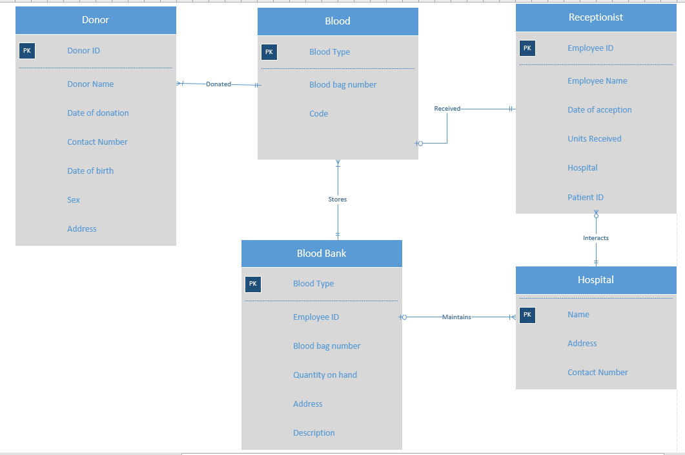

**n.Normalization**

Normalization basically has three form :

1.First Normal Form(1NF)

2.Second Normal Form(2NF)

3.Third Normal Form(3NF)

**First Normal Form(1NF)**

For a table to be in the First Normal Form It should follow the rules below:

1.It should only have single valued attributes.

2.Values stored in a column should be of the same domain.

3.All the columns in a table should have unique names.

4.And the order in which data is stored, does not matter.

**Second Normal Form(2NF)**

For a table to be in the 2nd Normal form,

1.It should be in the First Normal form.

2.It should not have partial Dependency.

**Third Normal Form(3NF)**

For a table to be in the 3rd Normal form,

1.It should be in the Second Normal form.

2.It does not have Transitive Dependency.

**Normalization of FIN database:**

1. **User(User_id,User_name,User_phone,User_email,User_password, User_sex)**

{User_id}=>{User_name}{functional dependency exist,because two different User_name do not correspond to the same User_id.

{User_id}=>{User_phone}{functional dependency exist}.

{User_id}=>{User_email}{functional dependency exist}.

{User_id}=>{User_password}{functional dependency exist}.

{User_id}=>{User_sex}{functional dependency exist}.

The attributes of this table does not have sub attributes, it is in the First Normal form(1NF).As every no-primary key attribute is fully funtionally dependent on the primary key of the table and it is already in the 1st Normal form ,this table is now in second normal form.

Again the table is in second normal form and no non-primary key attribute is transitively dependent on the primary key, the table is now in 3rd Normal form.

1. **Admin(Admin_id,User_id,Admin_name,Admin_mail,Admin_phone)**

{Admin_id}=>{User_id}{functional dependency exist}.

{Admin_id}=>{Admin_name}{functional dependency exist}.

{Admin_id}=>{Admin_mail}{functional dependency exist}.

{Admin_id}=>{Admin_phone}{functional dependency exist}.

The table is in first normal form.

The table is in second normal form.

The table is in third normal form.

1. **Blood_Donor(Donor_id,User_id,Donor_BloodGroup,Donor_age,Donor_Address)**

{Donor_id}=>{User_id}{functional dependency exist}.

{Donor_id}=>{Donor_BloodGroup}{functional dependency exist}.

{Donor_id}=>{Donor_age}{functional dependency exist}.

{Donor_id}=>{Donor_Address}{functional dependency exist}.

The table is in first normal form.

The table is in second normal form.

The table is in third normal form.

**o.Entity Mapping**

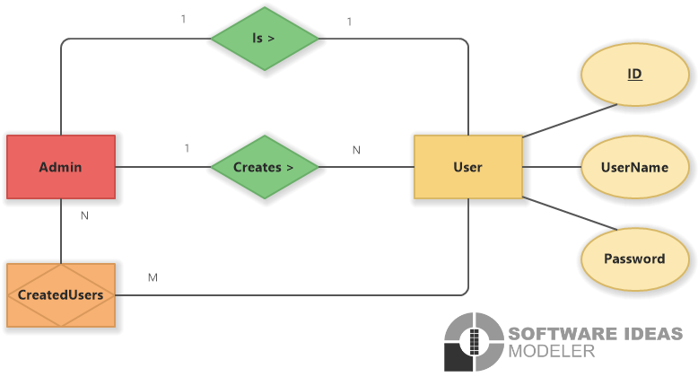

**p.Entity Realtionship Diagram**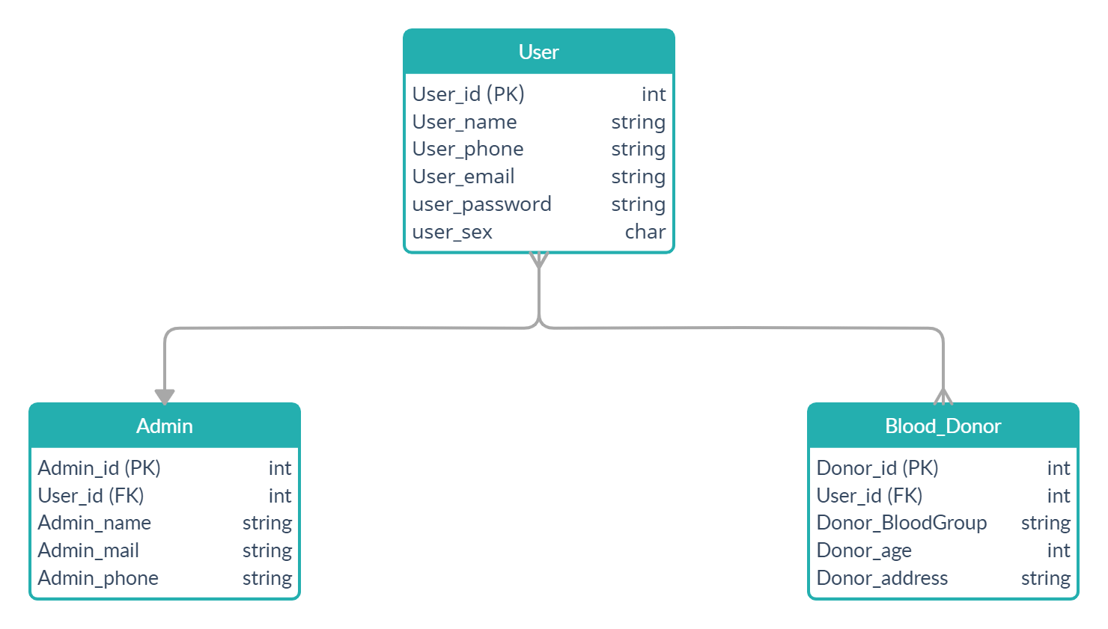

**4. Construction**

1. **Development Environment**
2. **Framework:** Android Studio
3. **Language:** Java
4. **Database:** Firebase
5. **Testing Strategy**

* We begin by testing-in-the-small and move testing in the large
* For conventional Software
* The module (component) is our initial focus
* Integration of Modules follow

1. **Testing Techniques**

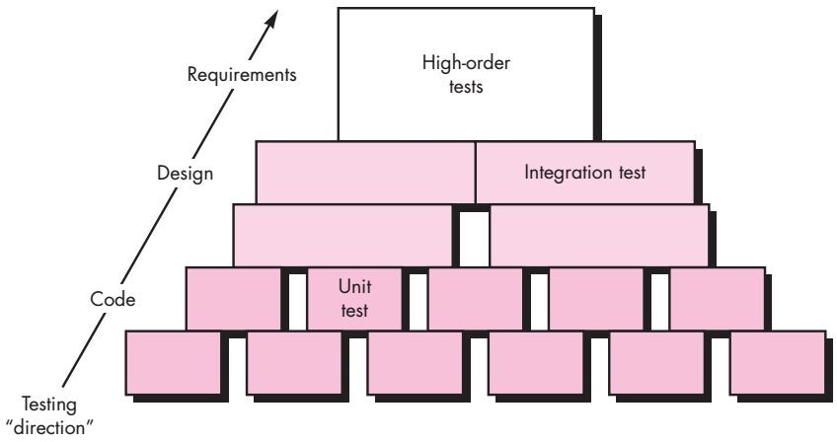

**5. Deployment**

**a) Deployment**

This application will be deployed in google play store in future. For right now we are providing drive link of the apk for installation of the app. Thus users can be benefited and also we will get customer review for future update.

**b) AMC**

Annual Maintenance Contract is all about the process to check the equipment's sold to the customers are well running and retaining the equipment keep running without any hazardous breakdowns happening. So we will keep track and record if “FIN” is harming any physical device anyhow.

**c) Support and Maintenance**

We Hope to continue supporting this application until October 2024. We will keep releasing updates until then and user feedbacks will be much appreciated for bug fixing.

**6. Learning Experiences**

There is no doubt working on projects help students to better understanding of theoretical concepts. But working on projects with elements of real world contributes even more to the connection between theory and practice. The involvement of real client requirements helped us to understand more deeply the specific of the system. Working as a team on the project improved our soft skills. We also learned how to follow a strong schedule, how to maintain working model and procedures, how to share responsibilities, how to communicate with others.

All these issues are actual challenges of every real-world projects. Having encountered them in a project at academic environment gave us the opportunity to overcome obstacles with our lecturers in more structured and disciplined way, using a lot of useful practices, presented in the courses.

**7. Conclusion**

To Conclude, FIN will be our useful friend during emergency time. Our safety will be at our fingertips. Hopefully, our life will be safer than ever.

**8. Bibliography / References:**

* [Yours for the making - Instructables](https://www.instructables.com/)
* [Big Think - Smarter, Faster](https://bigthink.com/)
* [Goodreads | Meet your next favorite book](https://www.goodreads.com/)

**Appendix**

1. I would define myself as _
2. I am aged between _
3. When you are in some emergency to whom do you contact / Where do you get help form?
4. Have you ever faced problem finding blood for an emergency patient?
5. Do you think an emergency app is needed which provide services such as (nearest police station, hospital, fire service, atm booth, filling station, blood donation etc.)?
6. Do you use smart watch?